**TCS Questions**

**Problem – 1**

Given an array of integers A, and an integer K find number of happy elements.

Element X is happy if there exists at least 1 element whose difference is less than K i.e. an element X is happy if there is another element in the range

[X-K, X+K] other than X itself.

**Constraints :**

**•** 1 <= N <= 10^5

• 0 <= K <= 10^5

• 0 <= A[i] <= 10^9

**Input :**

**•** First line contains two integers N and K where N is size of the array and K is a number as described above.

• Second line contains N integers separated by space.

**Output :**

**•** Print a single integer denoting the total number of happy elements.

**Example 1**

**Input :**

6 3

5 5 7 9 15 2

**Output :**

5

**Explanation :**

Other than number 15, everyone has at least 1 element in the range [X-3, X+3]. Hence they are all happy elements. Since these five are in number, the output is 5.

**Example 2**

**Input :**

3 2

1 3 5

**Output**

3

**Explanation :**

All numbers have at least 1 element in the range [X-2, X+2]. Hence they are all happy elements. Since these three are in number, the output is 3.

Possible Solution

**Input :**

3 2

1. 3 5

**Program :**

def HappyElements(A, K):

A.sort() # Sort the array in non-decreasing order

count = 0 # Initialize count to 0

n = len(A)

for i in range(n):

j = i + 1

while j < n and A[j] <= A[i] + K:

if A[j] >= A[i] - K:

count += 1

break

j += 1

return count

n, k = map(int, input("Enter Array length and K value : ").split())

A = list(map(int, input("Enter The Array Elemets : ").split()[:n]))

result = HappyElements(A, k)

print("No.of Happy Elemets are : ", result)

**Output :**

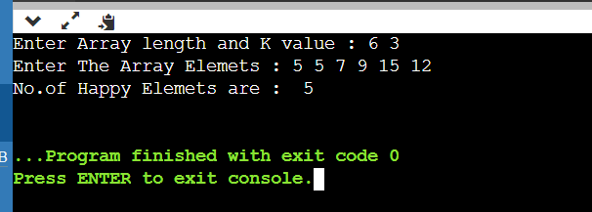

**Problem – 2 :**

Given two integer as the numbers, the objective is to check whether the ratio of the sum of the factors of a number except the number itself upon the number, for both numbers, matches or not using Java Language. To do so we’ll firstly find all the factors of the two numbers given as the input. Then we divide the sum with the numbers to get the ratio. Now we’ll compare both the ratios. For any pair of numbers to be a Friendly Pair, the ratio must match

Friendly Pair The numbers whose ( sum of divisors ) / number ratio is same are known as Friendly Pair Numbers.

Let's try and understand it better using an example

**Example**

**Input :** 6 28

**Output :** Yes, they are a friendly pair

**Explanation :**

The factors of 6 and 28 except the numbers themselves are 1, 2, 3 and 1, 2, 4, 7, 14 respectively.

Now the sum of factors of both the numbers are 6 and 28 respectively.

When we divide the sums with the numbers we get 1 and 1 respectively.

As the ratio of both the number match, they are considered as a friendly pair.

**Program :**

import java.util.Scanner;

public class Main

{

public static void main(String[] args)

{

Scanner input = new Scanner(System.in);

System.out.print("Enter first number: ");

int num1 = input.nextInt();

System.out.print("Enter second number: ");

int num2 = input.nextInt();

if (isFriendlyPair(num1, num2))

{

System.out.println(num1 + " and " + num2 + " are friendly pair numbers.");

}

else

{

System.out.println(num1 + " and " + num2 + " are not friendly pair numbers.");

}

}

public static boolean isFriendlyPair(int num1, int num2)

{

// Find the sum of factors for both numbers

int sum1 = 0, sum2 = 0;

for (int i = 1; i <= num1 / 2; i++)

{

if (num1 % i == 0)

{

sum1 += i;

}

}

for (int i = 1; i <= num2 / 2; i++)

{

if (num2 % i == 0)

{

sum2 += i;

}

}

// Calculate the ratio of sum of factors to the number itself

double ratio1 = (double) sum1 / num1;

double ratio2 = (double) sum2 / num2;

// Check if the ratios match

return ratio1 == ratio2;

}

}

**Output :**

